LMS Online Quiz – Questions Preview

Additionally teachers can preview all the questions of the quiz (or questions of the question bank) in “Adaptive mode” to have an idea about the grades computation upon correct and incorrect answers.
- Open the quiz summary page.
- Click on the “Actions Menu” icon and choose “Edit Quiz” from the dropdown menu.

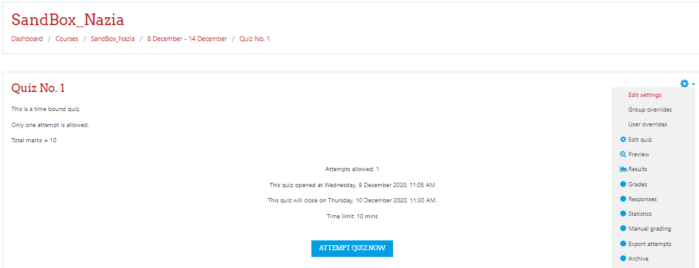

- To preview a question, click on “preview icon” (i.e. magnifying glass icon)

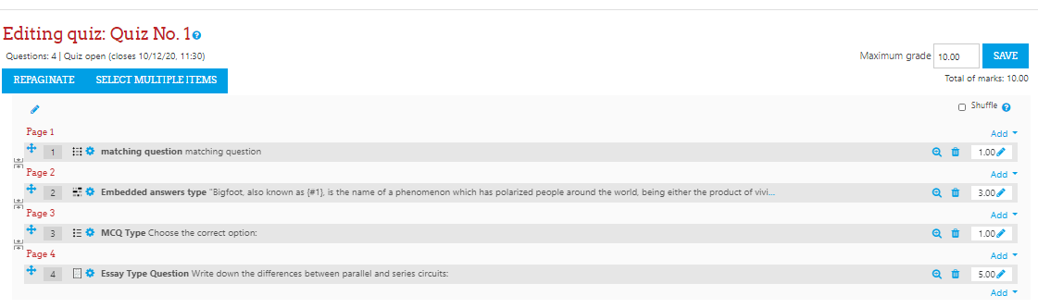

- Choose “adaptive mode” to analyze the behaviour of a question, selected answers and the marks calculations for students. Switching to “Adaptive mode” during question preview by the teacher is a temporary change, it will not change the default review settings of the quiz e.g. if deferred mode is set in the quiz settings, then it will remain the same.

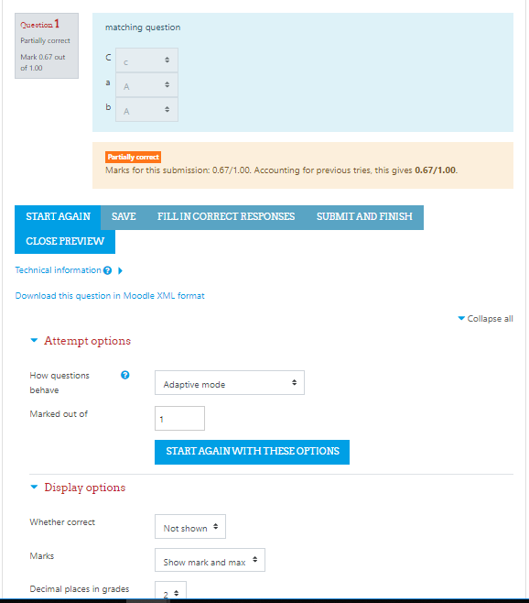

Note: It is recommended to preview all the questions and quiz if you are conducting the quiz very first time on LMS. This will provide you with a better understanding about the quiz module of LMS.

__________________________

